EXPERIEMNT 18: - To write a procedure to run the virtual machine of different configuration and to check how many virtual machines can be utilized at a particular time.

Step 1: - Open the existing virtual machine

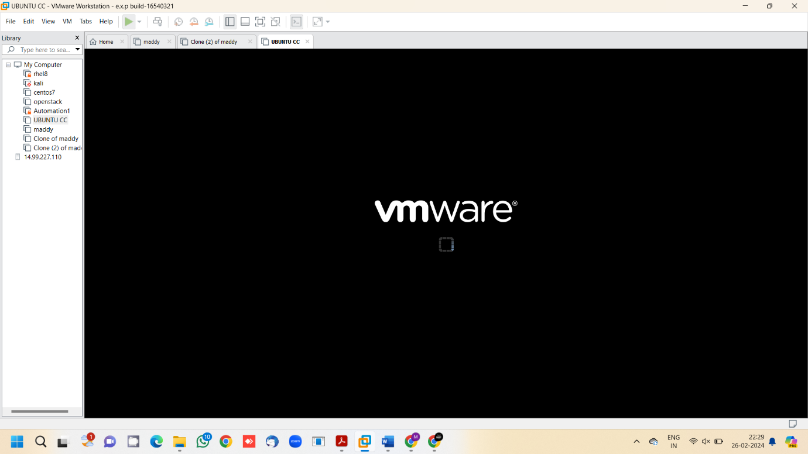

Step 2: - Type your desired c program and save it.

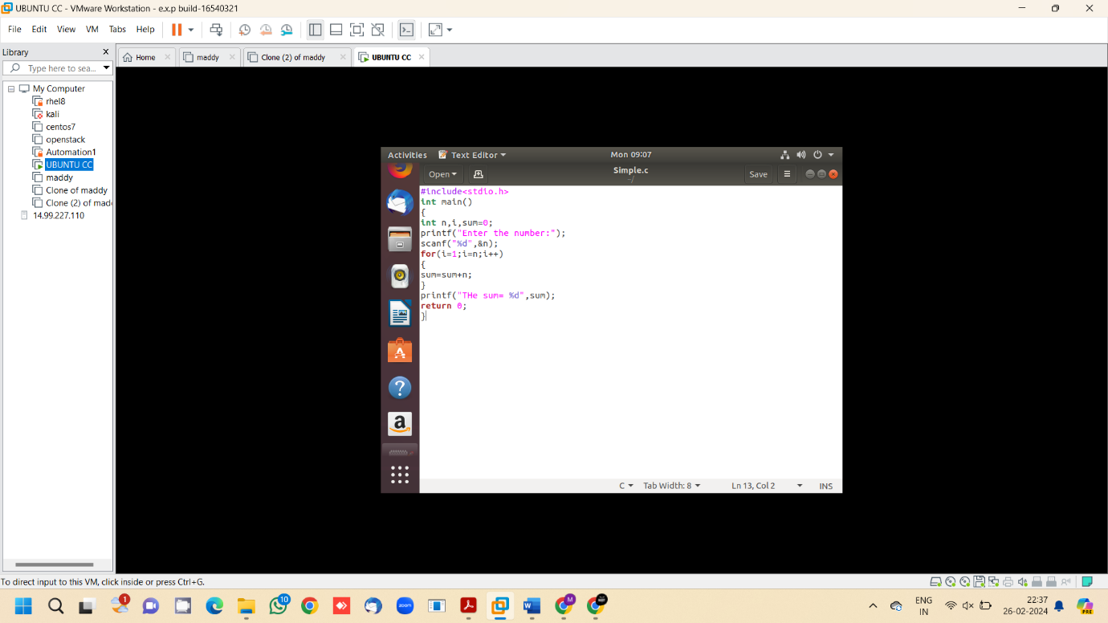

Step 3: - Open terminal

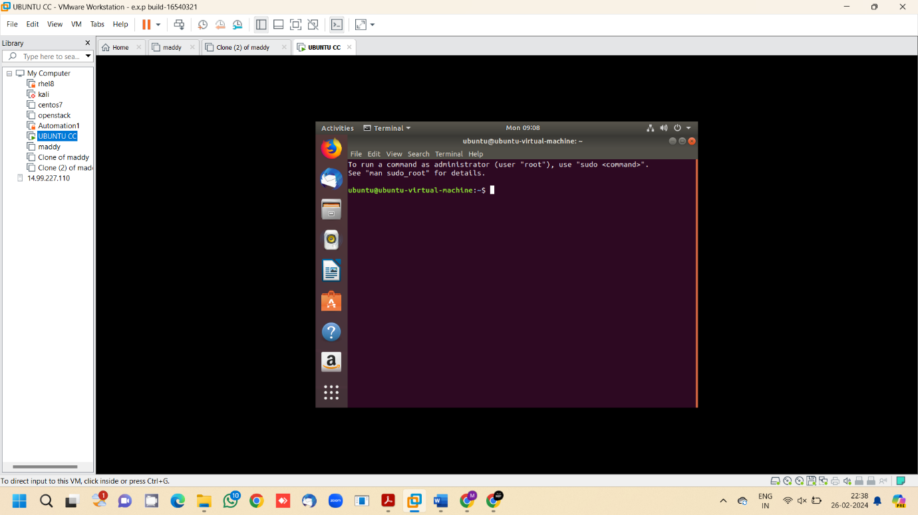

Step 4: - Execute the c program using terminal

